**Single approval items:**

1. In your inbox you will see exactly how many action items you have.

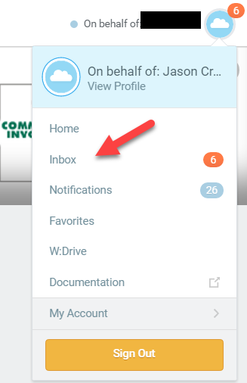

1. Once in your inbox choose the drop down to apply filters to your inbox such as One time payments above $2000.00, or job changes only.

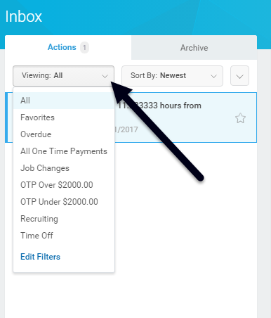

1. You can now choose the employee and amount you want to approve and approve it. You also have the option to send back with comments.

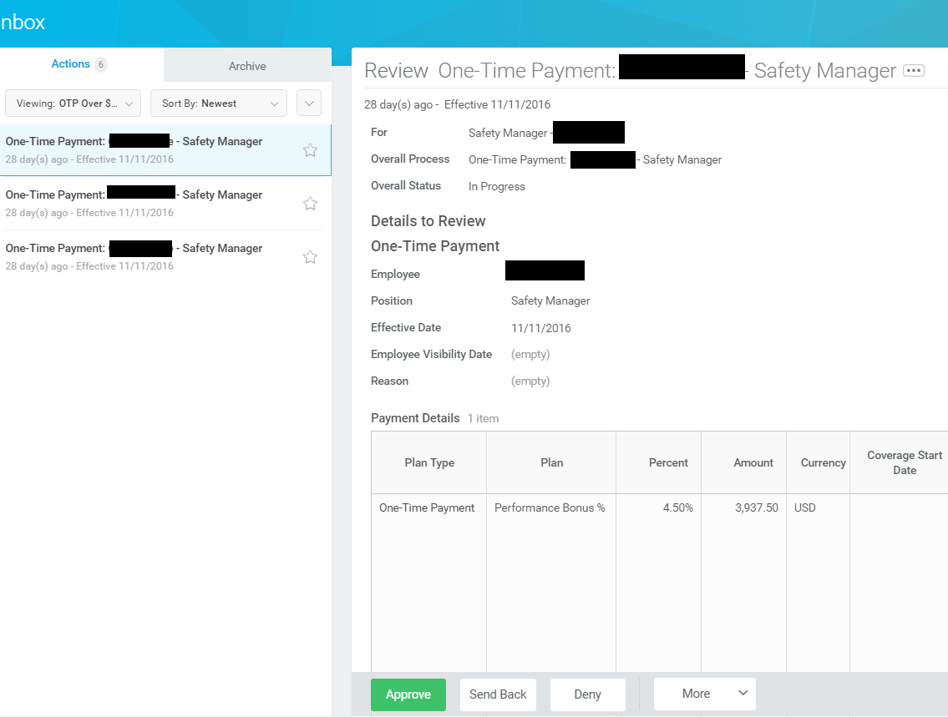

**Bulk Approving items:**

1. Select the right drop down arrow ‘Bulk Approve’

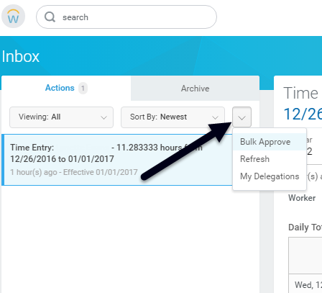

1. Now you can approve all the one time payments in your inbox OR you you also have the option to only select ceartin OTPs for approval by checking or not checking their box.

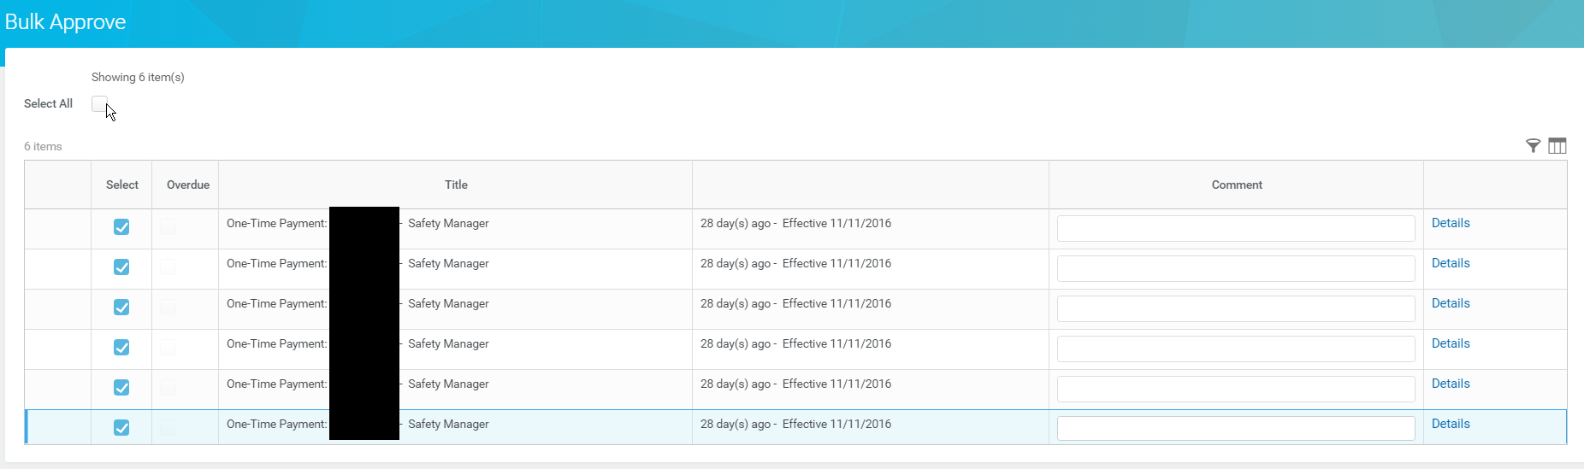

Another feature here is you can click on any header and search for only certain keywords to approve such as “safety bonus”.

**One Time Payment Report**

1. You also have reports you can run that will pull all of your one time payments and what the approval status is. In the search bar type in WCI In Progress One Time Payments.

